# Macine Learning and Data Mining

## 1.The Problem of learning

Tree essence of machine learning

(1)A pattern exists

(2)Can not pin it down mathematically

(3)Go to Ask data.

Machine Learning:

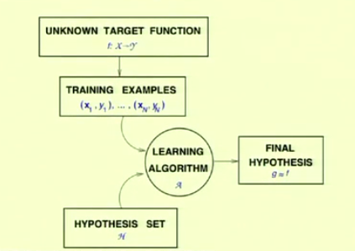

g funtion is our hypothesis and t is the target function.We try our best to make them look same.We make that $g ≈t$. We use the data with machine learning algorithm to make that come ture.

**Supervised learning:** Give you data(input,output)

**Unsuperivsed learning**:Give you data(intput,?).No output , but we can use usl to classificate data.

**Reinforcement learning**:Data(input,some output,grade for this output).

After we building a model with the exsit data, there an error ocurred when comes new data. Then we must fix the model(To minizing the error as we can).

## 2.The Feasibility of learning

Hoeffding’s Inequality

$$P\left[\left|υ-μ\right|> ε\right]≤2e^{-2ε^{2}N}$$

$υ$ is the possibility in the sample taken from the datebase.

$μ$ is the possibility in database.

$$P\left[\left|E_{out}\left(g\right)-E_{in}\left(g\right)\right|> ε\right]≤P\left[\begin{aligned}\left|E_{out}\left(h_{1}\right)-E_{in}\left(h_{2}\right)\right|> ε \\ or \\ … \\ or \\ \left|E_{out}\left(h_{M}\right)-E_{in}\left(h_{M}\right)\right|> ε\end{aligned}\right]$$

$$≤\sum_{i}^{M}{P\left[\left|E_{out}\left(h_{i}\right)-E_{in}\left(h_{i}\right)\right|> ε\right]}$$

$$P\left[\left|E_{out}\left(g\right)-E_{in}\left(g\right)\right|> ε\right]≤\sum_{i}^{M}{2e^{-2ε^{2}N}}$$

$$≤2Me^{-2ε^{2}N}$$

g is the target function. h is the hypothesis function. We use many database to correct our system. And we pick samples from that each database to test.And adjust the hypothesis function making it being close to the target function.

$E_{out}$ is the possibility of samples we picking from the database. And $E_{in}$ is possibility of the database.

## 3.The Linear Learning Model

(1)Input repressentation

(2)Linear Classification

(3)Linear Regression

(4)Nolinear Transformation

Linear Mode:

$$h\left(x\right)= \sum_{i}^{n}{w_{i}x_{i}}$$

We use this model as the hypothesis function.

And the error between the hypothesis value and true value.

$$Err=h-y$$

And the average error of the inside-examples is

$$E= \frac{1}{N}\sum_{n}^{N}{{(h\left(x_{n}\right)-y_{n})}^{2}}$$

$$E_{in}(w)= \frac{1}{N}{||Xw-y||}^{2}$$

Then we minimize the average error.

We get :

$$∇E= \frac{2}{N}X^{T}(Xw-y)$$

We make the $∇E$ = 0,so we get

$$X^{T}(Xw-y)=0$$

$$X^{T}Xw=X^{T}y$$

$$w={(X^{T}X)}^{-1}X^{T}y$$